# Heart Rate Processing Pipeline

As depicted in Figure 1, the Heart Rate (HR) processing pipeline is separated into two stages respectively called Inter Beat Intervals (IBI) Time Series Extraction stage and the HR Time Series Analysis stage.

The IBI Time Series Extraction stage process raw ECG waveform data recorded over a complete night and generates an IBI Time Series. The ECG waveform data in the pre-wake and post-wake periods are ignored in order to reduce the effects of motion artifacts. The Sleep Stage Scoring file provides the data necessary to evaluate the pre-wake and post-wake periods.

The IBI Time Series generated in the first stage is the data source processed in the HR Time Series Analysis stage. This second stage process the IBI Time Series and the Sleep Stage Scoring data to extract sleep specific statistics, compute Heart Rate Variability time domain parameters and perform linear regression modeling of the HR Time Series. The data results are saved in a summary file, the content of which is described in another document.

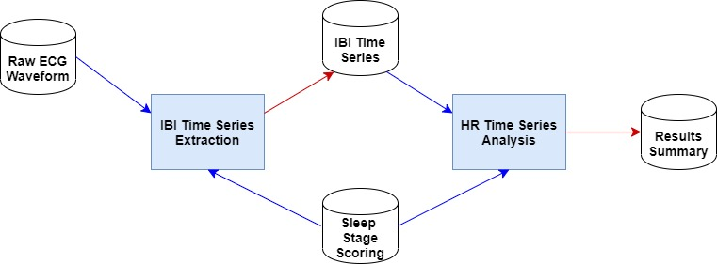

Figure 1. Hear Rate Processing Pipeline.

The next two sections provide detail descriptions of both the IBI Time Series Extraction and the HR Time Series Analysis stages.

Both stages have been implemented and executed in Matlab (R2019b).

# IBI Time Series Extraction Stage

The block diagram in Figure 2 provides an illustration if the different sub-stages constituting the IBI Time Series Extraction pipeline stage. An IBI time series is extracted from raw ECG signal data recorded across an entire night with the exception of the Pre-wake and Post-wake periods. With the exception of the first step (Pre-Wake and Post-Wave data Removal), this processing stage is a direct implementation of the dual adaptive thresholding algorithm of Pan-Tompkins [1, 2, 3]. The raw ECG data in the Pre-Wake and Post-Wave periods was not processed as it contains a large amount of motion artifacts.

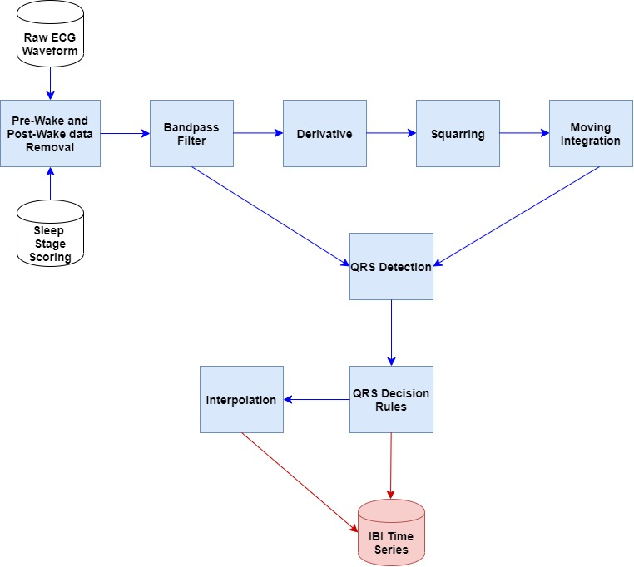

Figure 2. Block diagram of the IBI Time Series Extraction stage.

The IBI Time Series Extraction pipeline stage is composed of the Pre-processing, QRS Detection and QRS Decision steps. In the Pre-processing step, the raw ECG data is first filtered using a Butterworth bandpass filter (5 - 15 Hz) to reduce the influence of some artifacts. The filtered ECG signal is then differentiated using a five-point derivative schema to provide the QRS slope information. The squaring of the differentiated signal is to emphasize the higher frequencies and the following moving-window integration (32-sample window) is to obtain the waveform features of the of the QRS complex. Both the bandpass-filtered ECG signal and the window integrated signal are used in the QRS Detection stage of the pipeline.

Potential QRS complexes are detected in the QRS Detection stage of the ECG processing pipeline. The detection is performed by applying adaptive dual thresholds on the window integrated signal and the filtered ECG data. The filtered bandpass signal is also used to pin-point the R-wave peak and to provide an estimate the corresponding QRS width. Both the R-peak value and the QRS width are validated against respective thresholds. The output of the QRS Detection stage is a list of time locations (fiducial marks) corresponding to potential QRS complexes.

The fiducial marks are further validated in the QRS Decision Rules stage. First, the IBI time series is estimated as the time difference between the fiducial marks. IBI values are then validated against acceptable physiological values corresponding to Heart Rates in the 25 – 250 beats/minute [4]. The stability of the IBI values is also taken into account by guarding them against the averages of last eight valid IBI values. Identified missed-beats are interpolated using a cubic spline interpolation [5].

# HR Time Series Analysis stage

The processing steps composing the HR Time Series Analysis pipeline stage are shown in the block diagram of Figure 3. Most of the processing in this stage are based on the premise of time epochs each with a duration of 30 seconds. The Sleep Stage Scoring data consist of a sleep stage attributed to each epoch of 30 seconds across the complete night. Each epoch is manually attributed a sleep stage value of either *WAKE*, *NREM 1*, *NREM 2*, *NREM 3* or *REM* based on the observation of EEG recorded data for the corresponding time period. The Sleep Stage Scoring data for a complete night is stored in a text file that is read by a Matlab script.

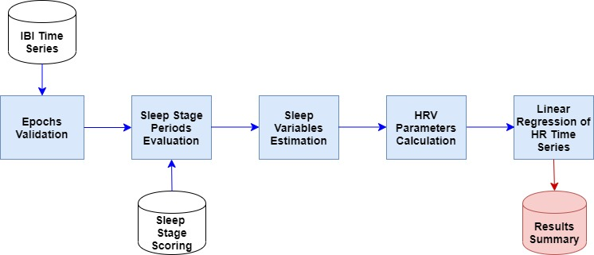

Figure 3. Block diagram for the HR Time Series Analysis stage.

## Epoch Validation

A data validation step is performed on the IBI time series in order to reduce the amount of data contaminated with motion artifacts. This validation is carried out on an epoch time basis.

The following processing steps are performed for each epoch of 30 seconds:

* Summation of all IBI values (*SumIBIs*) in the time epoch;
* If the *SumIBIs* value is within the time interval [29.7,30.3] seconds (30 seconds ±1%) then the epoch is considered valid;
* If the *SumIBIs* value is NOT within the time interval [29.7,30.3] seconds (30 seconds ±1%) then the epoch is considered non-valid;
* Exclude all IBI values from the IBI time series that corresponds to non-valid epochs.

## Sleep Stage Periods Evaluation

Using the Sleep Stage Scoring data, Pre-Wake, Post-Wake, NREM and REM periods are inferred. The sleep stage periods deduced from the following rules:

### NREM Periods

* Starts with the first epoch of Stage 2, 3, or 4 (indicated in txt file as either "Stage 2, Stage 3, or Stage 4" or "NREM2, NREM3, or NREM4");
* Ends with the epoch preceding the first epoch of REM (indicated in txt file as "REM") **or** the last period of wake (indicated in the txt files as "Wake") of a continuous bout of at least 5 minutes of REM (no duration criteria for the first and last REM periods) or Wake (only the last bout of wake in the end of the recording; in the end, there should be no "wake" period cutting the NREM in the middle );
* At least 15min duration.

### REM Periods

* Time intervals between two consecutive NREM period**or**the time interval between the last NREM period and the final awakening (indicated in the text file as continuous "Wake" epochs until the end of the recording);
* At least 5 min duration but no minimum duration for the first and last REM episode
* (Thus **occasional stage 1 epochs**between REMS and stage 2 are included in the REM episode);

### Pre-Wake Period

* Time intervals between the start of the recording and the first NREM and REM period.

### Post-Wake Period

* Time intervals between the last NREM and REM period until the end of the recording.

## Sleep Variables Estimation

The following sleep variables are computed and stored:

|  |  |
| --- | --- |
| **Lights OFF**  **Lights ON** | Time at which one starts trying to fall asleep  Time at which one is woken up (or recording ends) |
| **TiB** | **Time in Bed**; time between Lights OFF and Lights ON |
| **SOL** | **Sleep Onset Latency**; Time between Lights OFF and the 1st epoch of sleep  (i.e. how long does it take to fall asleep) |
| **REM_Lat** | **Rem Latency**; Time between 1st epoch of sleep and 1st epoch of REM |
| **TST** | **Total Sleep Time**; Time during the recording that was spent asleep |
| **WASO** | **Wake After Sleep Onset**; Time between 1st epoch of sleep and end of recording that was spent awake.  From Rebecca’s email sent on Tuesday February 8 2020.  *WASO = Wake after sleep onset*  *= Starting from first period of sleep and until the last period of sleep in the recording, all the epochs scored as wake (ca comprend les mini-reveils*durant*la nuit)* |
| **Sleep Efficiency** | =(**TST** / **TiB** ) *100  Reflects how consolidated/fragmented sleep is |
| **N1_min** | Absolute Sleep Stages  Number of minutes spend in each sleep Stage |
| **N3_min** |
| **N3_min** |
| **REM_min** |
| **N1_PC** | Relative Sleep Stages  Percentage of Total Sleep Time spend in in each  sleep Stage (e.g. = (**N1/Total Sleep Time**) *100 ) |
| **N3_PC** |
| **N3_PC** |
| **REM_PC** |

The duration of the Pre-Sleep, REM, NREM and Post-Sleep periods are also computed and stored.

## HRV Parameters Calculation

Two time-domain HRV parameters and mean HR values are computed in the HRV Parameters Calculation step. The time-domain HRV parameters are computed from the IBI time series.

### Root Mean Square of Successive Differences per Epoch

The Root Mean Square of Successive Differences (RMSSD) is the first parameter that is computed. Its calculation is repeated for each epoch as follow:

$${RMSSD}_{i}=\sqrt{\frac{\sum_{j=2}^{N_{i}}{{\left({IBI}_{i,j+1}-{IBI}_{i,j}\right)}^{2}}}{N_{i}-1}} ,$$

where

*N*i is the number of IBI values in the *i*th epoch,

*IBIi,j* is the *j*th IBI value in the ith epoch,

*i* = 1, 2, … *Ne*,

*Ne* is the total number of 30-second epochs.

### Standard Deviation of IBIs per Epoch

The standard deviation of IBIs (SDNN) is the second time-domain HRV parameter computed. Its calculation is also repeated for each epoch according to the following relation:

$${SDNN}_{i}=\sqrt{\frac{\sum_{j=1}^{N_{i}}{{\left({IBI}_{i,j}-{AvgIBI}_{i}\right)}^{2}}}{N_{i}}} ,$$

where

*N*i is the number of IBI values in the *i*th epoch,

*IBIi,j* is the *j*th IBI value in the *i*th epoch,

*AvgIBIi* is the average IBI values in the *i*th epoch,

*i* = 1, 2, … *Ne*,

*Ne* is the total number of 30-second epochs.

### Average Heart Rate per Epoch

The HR time series values are obtained from the IBI time series using the following relation:

$$HR\left(t\right)=\frac{60}{IBI\left(t\right)} ,$$

where the IBI values (*IBI(t)*) are in seconds.

The resulting HR values are thus given in Beat per Minute (BPM).

The average HR values per epoch are computed as follow:

$${HR}_{i}=\frac{\sum_{j=1}^{N_{i}}{\frac{60}{{IBI}_{i,j}}}}{N_{i}} ,$$

where

*N*i is the number of IBI values in the *i*th epoch,

*IBIi,j* is the *j*th IBI value in the ith epoch,

*i* = 1, 2, … *Ne*,

*Ne* is the total number of 30-second epochs.

### HRV Parameter per Sleep Stages

Once the HRV parameters are computed for each epoch, the following values are calculated:

|  |  |
| --- | --- |
| **Parameter** | **Description** |
| RMSSDN1 | Mean RMSSD value over all epochs scored as NREM 1. |
| SDNNN1 | Mean SDNN value over all epochs scored as NREM 1. |
| HRN1 | Mean HR value over all epochs scored as NREM 1. |
| RMSSDN2 | Mean RMSSD value over all epochs scored as NREM 2. |
| SDNNN2 | Mean SDNN value over all epochs scored as NREM 2. |
| HRN2 | Mean HR value over all epochs scored as NREM 2. |
| RMSSDN3 | Mean RMSSD value over all epochs scored as NREM 3. |
| SDNNN2 | Mean SDNN value over all epochs scored as NREM 3. |
| HRN3 | Mean HR value over all epochs scored as NREM 3. |
| RMSSDNREM | Mean RMSSD value over all epochs scored as NREM 1, NREM 1 or NREM 3. |
| SDNNNREM | Mean SDNN value over all epochs scored as NREM 1, NREM 1 or NREM 3. |
| HRNREM | Mean HR value over all epochs scored as NREM 1, NREM 1 or NREM 3. |
| RMSSDREM | Mean RMSSD value over all epochs scored as REM. |
| SDNNREM | Mean SDNN value over all epochs scored as REM. |
| HRREM | Mean HR value over all epochs scored as REM. |
| RMSSDWAKE | Mean RMSSD value over all epochs scored as WAKE. |
| SDNNWAKE | Mean SDNN value over all epochs scored as WAKE. |
| HRWAKE | Mean HR value over all epochs scored as WAKE. |
| The following three parameters are computed for all NREM stage periods. | |
| RMSSDNREMpX | Mean RMSSD value over all epochs in stage period NREM number X. |
| SDNNNREMpX | Mean SDNN value over all epochs in stage period NREM number X. |
| HRNREMpX | Mean HR value over all epochs in stage period NREM number X. |
| RMSSDNREMp | Mean RMSSD value over epochs in all NREM stage periods. |
| SDNNNREMp | Mean SDNN value over epochs in all NREM stage periods. |
| HRNREMp | Mean HR value over epochs in all NREM stage periods. |
| The following three parameters are computed for all REM stage periods. | |
| RMSSDREMpX | Mean RMSSD value over all epochs in stage period REM number X. |
| SDNNREMpX | Mean SDNN value over all epochs in stage period REM number X. |
| HRREMpX | Mean HR value over all epochs in stage period REM number X. |
| RMSSDREMp | Mean RMSSD value over epochs in all REM stage periods. |
| SDNNREMp | Mean SDNN value over epochs in all REM stage periods. |
| HRREMp | Mean HR value over epochs in all REM stage periods. |

## Linear Regression of HR Time Series

The last step in the HR Time Series Analysis pipeline stage consist in fitting linear regression model to different parts of the HR time series.

First, a linear regression model is fitted to the complete HR time series (complete sleep night without the Pre-wake and Post-wake periods).

In addition, different linear regression models are fitted to segments of the HR time series corresponding to REM and NREM sleep stage periods.

The slope, intercept, R2 and confidence interval factor are estimated and stored for each linear regression models.

# References

[1] Arzeno NM, Deng Z, Poon C, Analysis of First-Derived Based QRS Detection Algorithms, IEEE Trans Biomed Eng 2008; 55(2): 478-484

[2] Hamilton PS, Tompkins WJ. Quantitative investigation of QRS detection rules using MIT/BIH arrhythmia database. IEEE Trans Biomed Eng 1986; 12: 1157-1165.

[3] Pan J, PS, Tompkins WJ. A real-time QRS detection algorithm. IEEE Trans Biomed Eng 1985; 32(3): 230-236.

[4] Vila J, Palacios F, Presedo J, Fernández-Delgado M, Félix P, Barro S (1997) Time-frequency analysis of heart-rate variability. Eng Med Biol Mag IEEE 16(5):119–126

[5] Clifford GD, Tarassenko L, Quantifying error in spectral estimates of HRV due to beat replacement and resampling, IEEE Trans Biomed Eng 2005; 52(4): 630-638.